Teenage safety project
MA-4-4-012
March 2006

MA-4-4-012 FINAL REPORT

EXECUTIVE SUMMARY 3
Project aims 3
Methodology 3
Steering group 3
Schools pilot studies 3
Outcomes 4
Conclusions 4
PROJECT AIMS 5
The problem 5
Disused quarries 5
Play Safe … Stay Safe 5
METHODOLOGY 6
Quarry managers’ survey 6
Safety hotspots 7
Benchmarking research 7
Accident case studies 8
Quotes 9
STEERING GROUP 9
PILOT STUDIES 10
Schools 10
Risk management 12
OUTCOMES 13

APPENDICES (attached)
Appendix I - Teenage safety campaign research
Appendix II - Sample press coverage
Appendix III - Relevance to the national curriculum
Appendix IV - Conference programme

EXECUTIVE SUMMARY

Project aims

The aim of the project was to develop a communications programme that can be used to tackle the problem of teenage trespass in quarries and so save lives that are being put at risk. The project built on the Quarry Product’s Association’s (QPA) successful Play Safe ... Stay Safe campaign, which has been delivering the safety message to children, parents and teachers over the past seven years. The QPA recognised, however, that the industry’s greatest trespass problem lies with teenagers and young adults and that communicating with them required a different approach. Feedback from quarry managers had indicated that it was difficult to engage this group with existing materials and that a more innovative and creative approach to the problem was required.

Methodology

The project centred on four pilot studies in schools located within key quarrying areas. The schools were asked to engage students in developing a communications programme for their peers. However, the project incorporated several other key elements that were drawn together and presented at an industry conference in March 2006, including:

- A survey of quarry mangers’ perceptions of quarry trespass
- Assessment of previous accidents
- Identification of safety “hotspots” – quarries where accidents are “waiting to happen”
- A benchmarking exercise to review other industry sectors’ approaches to teenage trespass
- Quarterly reviews by an expert steering group
- Development of an innovative module designed to help teenagers take a more mature attitude to risk
- Production of a managers’ guide with teachers’ resources to guide future projects
- Development of web-based resource on existing industry sites
- Development of a web-based game emphasising the safety message.

The survey highlighted that, despite the great efforts of companies to reduce trespass, the level of concern about trespass has increased by nine per cent over the last three years to 55 per cent.

Steering group

The project steering group advised throughout on the development of the project. It comprised of representatives from the companies and organisations detailed below.

Quarry Products Association (project manager)  Derbyshire Constabulary  Health and Safety Executive  National Stone Centre  Aggregate Industries  CEMEX | Hanson  Lafarge  Midland Quarry Products  Rotherham Sand and Gravel  Tarmac  Daybreak Communications

Schools pilot studies

The project team enlisted the support of four secondary schools in key quarrying areas, inviting each to pilot different approaches to the communication challenge: “how would you communicate to other teenagers the dangers of trespass in quarries?”

The four schools selected for the project were:

School | Location | Partners
Tividale Community Arts College | Oldbury West Midlands | Midland Quarry Products
Serlby Park School | Retford Nottinghamshire | Tarmac & Rotherham S&G
Frome Community College | Frome Mendips | Hanson & Foster Yeoman
Anthony Gell School | Wirksworth Derbyshire | Tarmac, CEMEX & MQP

The approaches taken by the schools showed originality and drew on a wide range of different media. This included the use of video, radio interviews, plays, animations, jingles, magazines, websites, sculptures and other printed material. The work produced will form a key element in the resource for use by teachers.

The feedback from the pilots highlighted a communications dilemma: many teenagers choose to “hang out” in quarries because they want risk and are fully aware of the dangers. Therefore, the project was extended to include the development of a unique teaching programme that specifically addressed issues associated with the management of risk and personal development generally. A leading learning analyst, Roy Leighton, was commissioned to develop and test the programme that would help teenagers to take a more mature attitude to risk.

Outcomes

The three key outcomes of the project were:

- to utilise the resources produced by the pilots and other feedback to enhance future safety campaigns run by the industry
- to use the knowledge and experiences gained during the project to produce a resource that can be used as a template by teachers and quarry managers to effectively engage with teenagers
- to communicate to the industry the project conclusions and make recommendations for their consideration.

Conclusions

The study resulted in nine key conclusions. The first six are directly relevant to the resource that has been developed to be used by quarry managers in liaison with local schools. The QPA will work closely with the major UK aggregate companies to ensure that this resource is utilised within the industry. Initially, it is envisaged that particular emphasis will be placed on using it within local schools near to quarries that have been identified as hotspots for teenage trespass.

The remaining two conclusions raise issues that fall outside the scope of this project. However, the feedback from the final conference clearly indicated that these were areas that required further exploration and, in some cases, government involvement.

- The problem of teenage trespass is a serious one. The industry has to be proactive in addressing this
- Success with teenagers comes not from talking at them but from engaging with them and their imaginations
- Projects that engage schools have to be relevant to the National Curriculum
- The resources produced by our pilot schools are good – but the big benefit came from simply doing them
- Teenagers could become ambassadors, delivering the quarry safety message to children as well as to their peers
- Many teenagers go to quarries because they want risk. Only a more mature general attitude to risk will change that
- Irresponsible adults are a major problem. Localised publicity in safety hotspots is our most effective weapon
- Disused quarries pose a distinct problem that has to be addressed on a site-by-site basis. First, we need to identify them
- Clear government ownership of the problem of public safety in industrial environments would achieve greater impetus.

PROJECT AIMS

The problem

Quarry trespass by children and young adults is one of the most worrying of all problems for the quarrying industry in the UK. Incidents over recent years include:

- 13-year-old boy was buried alive when the tunnel he and friends were digging into a sand stockpile on a marine aggregate wharf in south Wales collapsed
- A 17-year-old boy drowned in a disused quarry lake in Somerset after apparently diving from a cliff face
- A 14-year-old girl broke an arm and leg when she fell down a cliff face at a quarry in the West Midlands after horseplay with friends.

Disused quarries

Disused quarries pose a particular problem in some areas because they are great magnets for young people – and are often unattended. The ownership of some historic sites is unclear and those that are still owned by QPA members often find it impossible to keep the public out.

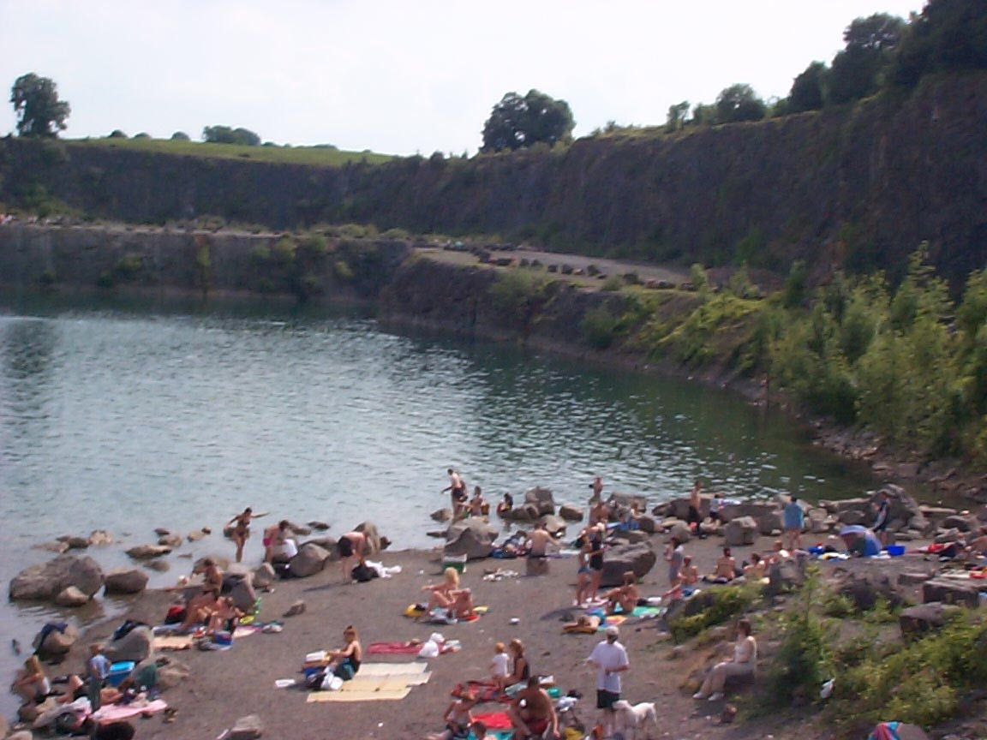
At one site in Somerset, several hundred people have been photographed bathing on a typical summer afternoon – a high percentage of them young adults who were diving from high faces into deep and numbingly cold water with a host of hidden underwater obstructions. In that case, steel fence posts had been literally dragged out of the ground using heavy vehicles in order to maintain illegal access.

While adults have much to answer for at such sites, teenagers are undoubtedly taking the greatest risks.

Given that the problem with disused quarries extends to companies and individuals that are outside its membership, the QPA is keen to share the outcomes from this project as widely as possible in the general public interest.

Play Safe … Stay Safe

The Quarry Products Association runs an annual Play Safe … Stay Safe campaign to carry the safety message to children and to the adults that influence them – mainly parents and teachers. Its message goes out nationwide through the media but also functions successfully at local level.

The main elements of the campaign are:
- A survey of quarry managers (as detailed above)
- A teachers’ resource pack with projects for children at Key Stages 2 and 3
- A schools wallchart
- Warning signs and posters for quarries
- A video featuring TV presenter Katy Hill (updated in 2003 to place new emphasis on resisting peer pressure)
- A media campaign at national and local level
- Letters to local newspaper editors
- Schools visits by quarry managers
- Organised class visits to quarries
- Industry involvement in localised safety campaigns
- Emphasis on safe places to play
- Support from the HSE, all emergency services, Life Savers and RoSPA.

The campaign is typically focussed around the Whitsun bank holiday weekend as the time of year when children begin to turn their attention to outdoor adventure.


England goalkeeper David James fronted the 2004 campaign

It is very difficult to measure the success of any campaign of this sort on the basis that you can’t count accidents that didn’t happen! There is, however, general agreement amongst quarry managers that the campaign helps them in a major way to get the message across.

The QPA acknowledges, however, that much more needs to be done to persuade young adults of the dangers of trespassing in quarries. The style of warnings that prove effective with younger children are, quite understandably, not effective with older age groups who resist being told what to do. New answers need to be found – not least in helping to resist peer pressure.

METHODOLOGY

The project consisted of four pilot studies in schools located within key quarrying areas who were asked to develop a communications programme for their peers. However, the project incorporated several other key elements that were drawn together and presented at an industry conference in March 2006, including:

Quarry managers’ survey

160 managers responded to an industry questionnaire on quarry safety that helped to update benchmark figures from an earlier survey in 2004 on quarry managers’ concerns in relation to quarry safety.

Key points revealed from the survey included:

- 55 % were concerned about trespass
- … 9 % more than in 2004
- 6 trespass-related accidents had occurred in the last three years
- Adult trespass was more common than youth in 85 % of cases
- Breaking down fences was top of managers’ concerns
- 81 % of managers are actively trying to remedy the problem
- 22 managers mentioned trespass in local disused quarries.

Although great progress has been made by quarrying companies to remedy the problem, such as through school visits and extensive on-site security, trespass remains a major problem at some sites.

The survey also showed the true extent of the adult trespass problem. In 70 per cent of cases, this was associated with leisure activities, such as dog-walking. Although the intention is usually harmless, these individuals are setting a poor example for the younger generation. Through breaking down fences, they create a gap which could provide easy access for youngsters on subsequent days.

Safety hotspots

The survey identified those areas where quarry managers had a high level of concern in relation to trespass. This information will be used to help focus industry activity to develop targeted and localised communication programmes at the local level that will draw on the resources develop from the project.

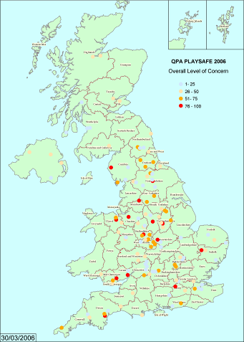
UK map summarising level of concern of quarry managers – the red dots indicate particular concern

Benchmarking research

The project team undertook an extensive benchmarking exercise consisting of both background research and discussions with other organisations surrounding safety campaigns targeting teenagers in England. In conjunction with the conclusions drawn from the pilot schools projects, this research was intended to provide a broad representation of the methods available for reaching teenagers with key quarry safety messages.

The team studied a wide range of online resources intended to be accessed by members of the public, with the common aim of communicating specific safety messages to teenage audiences, including:

- Department for Transport – Traffic Safety
- Childnet International – Chatroom Danger
- The Fire Kills Campaign – Get Firewise (designed for 8-14 years)
- Department for Transport – Cycle Sense
- Department for Health – Sun Safety
- NHS – Think About Drink
- UK Government – Talk To Frank
- Network Rail – No Messin’

Members of the project team also conducted a series of consultation meetings with representatives from the Environment Agency and RoSPA, as well as industries with corresponding safety issues, such as the Rail Industry Community Support Unit. A report reviewing websites relating to teenage safety is included as Appendix I.

Accident case studies

The study examined a number of specific incidents that involved accidents following teenage trespass into a quarry. One incident in particular involving Abi Cosnett was used to help brief the pilot schools on the events leading up to and the consequences of an accident in a quarry. The school which she attended became one of the pilot schools in the project. The examples below involving an operational and a disused quarry provide good illustrations of the problem.

A narrow escape

It was an ordinary day for 14-year-old Abi Cosnett – a chance to catch up with friends after a brief holiday. But it ended abruptly when she fell 50 feet down a quarry and had a narrow escape from death.

Abi fell down Edwin Richards Quarry at Oldbury in the West Midlands in June 2004. She and a small group of friends got into the site through fencing which operators Midland Quarry Products believe had been cut by adults. One of the boys who was with Abi also fell but escaped injury. Quarry manager, Ray Tyrer, recalls: “She was lying in an inaccessible spot and initially we had no idea how badly she was hurt. There was a real risk she could fall further, in which case she could well have been killed.” She was involved in a dramatic three hour helicopter rescue involving a paramedic and a fire brigade rope team.

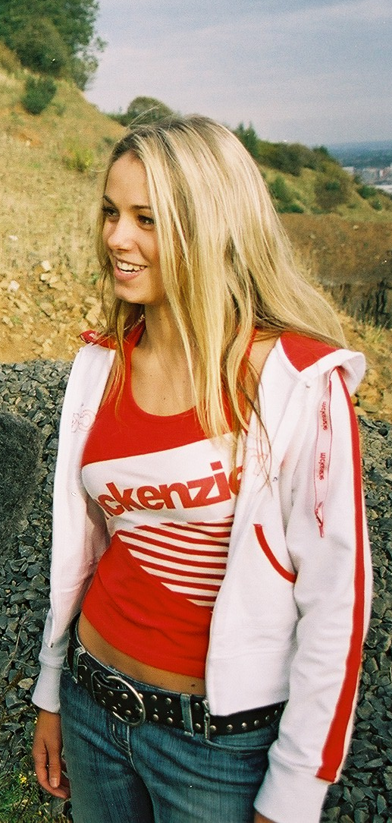
Abi’s injuries were serious – she broke an arm and leg and badly bruised her kidneys. “I was very lucky to get away with injuries because I could easily have died,” says Abi. “Quarries are safe places for the men who work there but they are not good places for people of my age to hang out. Anything the Quarry Products Association can do to get the message across has got to be good and I am happy to support the campaign.”
The rescue has been reconstructed for a video that is available to schools across the country. Abi’s school is one of the four taking part in the pilot research project designed to find new ways of discouraging teenagers from treating quarries as fun places.

Tragedy at a disused quarry

Sadly, not all teenagers who trespass in quarries are as lucky as Abi. A Somerset teenager drowned at a disused quarry in Holcombe, near Shepton Mallet. Along, with two friends, the 17-year-old dived from the cliff face into the deep and numbingly cold water. While his friends survived, the boy tragically drowned.

Several hundred people have been photographed bathing on a typical summer afternoon at the quarry (left) and diving from high faces.
Hanson, the company which owns the site, had employed security guards and put up notices. It had also repaired fences and placed boulders to stop people getting in, but they had been dragged out of the ground using heavy vehicles in order to maintain illegal access.
Disused quarries pose a particular problem in some areas because they are great magnets for young people – and are often unattended. The ownership of some historic sites is unclear and those that are still owned by QPA members often find it impossible to keep the public out.

Other incidents at quarries over recent years include:
- A 14-year-old boy drowned while swimming at a quarry near Liverpool
- A boy of 17 drowned in a lake at a quarry near Wigan, Lancashire
- A trail bike rider died after colliding with a stationary lorry in a quarry near Derby
- A 13-year-old boy was buried alive when the tunnel he and friends were digging into a sand stockpile on a marine aggregate wharf in south Wales collapsed
- A teenager suffered a broken leg and head injuries falling off a motorcycle after gaining access via a public footpath near Esher
- A fractured skull and pelvis was the outcome when a 15-year-old Durham teenager lost his footing and fell nearly 40 feet into Hawthorn Quarry in Seaham.

Quotes

“The HSE fully supports and applauds the QPA's initiatives to educate children and young people not to put themselves and their friends at risk by playing in quarries.“
Rob Pearce, HSE
“Firefighters all too often have to risk their own lives in order to rescue children that have become trapped or injured as a consequence of playing in a quarry.”
Paul Young, The Chief and Assistant Chief Fire Officers’ Association

STEERING GROUP

The involvement of a high level steering group was considered to be a key element contributing to the success of the project. The steering group incorporated representatives from the Health and Safety Executive, the emergency services, and industry representatives with expertise in communications, health and safety and operations. The steering group met quarterly, reviewing progress and agreeing the next stages of the project. The members of the steering group are detailed below:

Organisation | Name | Job title
Quarry Products Association | Timothy Parry  Elizabeth Clements | Communications Manager  Communications Director
Derbyshire Constabulary | Jim Allen  Robert Smallwood  Kul Mahay | Police Constable  Sergeant  Chief Inspector
Health and Safety Executive | Rob Pearce | HM Principal Inspector
National Stone Centre | Ian Thomas | Director
Aggregate Industries | Mike Aves | Commercial Services Manager
CEMEX | Marit Meyer-Bell | Senior Communications Executive
Hanson | David Weeks | Head of Communications
Lafarge | Andi Hodgson  April Leary | Head of PR  PR Manager
Midland Quarry Products | Cedric Hollinsworth | Managing Director
Rotherham Sand and Gravel | Edward Codd | Site Foreman
Tarmac | Vicky Fletcher  Alison Garrett | Head of PR  PR Officer
Daybreak Communications | Barrie Hedges | Communications Director

PILOT STUDIES

The project team enlisted the support of four secondary schools in key quarrying areas, inviting each to pilot different approaches to the communication challenge – how would you communicate to teenagers the dangers of trespass in quarries? The schools submitted outline plans for projects that ran between the 1st April 2005 and 31st July 2005. The culmination of the project was a written report and presentation to partners who had been involved in the projects at a local level. These presentations were reported to the local media and, in one case, received coverage on the regional TV and radio news. Appendix II shows samples of the press coverage received for the projects.

The activities of the schools are summarised below and clearly demonstrate the variety of approaches that were taken. The teachers involved with the project were requested to provide a report on the process and their assessment of how effective the pilot had been. The schools presented to the Reassessing Risk teenage safety conference in March 2006.

One overwhelming conclusion from the initial schools projects is that you cannot hope to change teenagers’ behaviour unless you change their thinking. Success comes not from talking at them, but from engaging with them and their imaginations.

From the pilot schools projects, we’ve also learnt that it isn’t so much the resources themselves, but the actual production process that is really significant in spreading key safety messages. The students who have worked on these projects have not just have taken in the messages themselves, but will also have spread the word to both their peers and younger children.

The pilots undertaken by the schools are summarised below and the presentations from the conference are included on the DVD provided with this report.

Schools

Tividale Community Arts College

Tividale Community Arts College in Oldbury consists of 1,100 students aged 11 to 18 and is located in the heart of the West Midlands quarrying industry. Two years ago, 14-year-old Abi Cosnett, a student at the college, had a narrow escape when she fell 50 feet down a nearby quarry, breaking her arm and badly bruising her kidneys.

The project team consisted of six students led by deputy head Louise Blount, who were invited to apply for involvement and were each given a specific creative role. The team decided to produce an advertising campaign aimed at a teenage audience, consisting of computer animation, graphic design and photography using a contemporary ‘pop art’ style.

As part of a three-day intensive workshop, the team undertook a research visit to the nearby Edwin Richards Quarry where Abi was injured, to consult with staff from industry project partners Midland Quarry Products.

The students took photos for the final campaign elements, and then commissioned a team of community arts specialists to help animate their still images into a powerful quarry safety animation. To create a character that convincingly mimicked human movement, one member of the team acted as a model in the studio.

The team also produced a series of promotional postcards to inform teenagers focussing on the everyday end products produced by quarries – again selecting a contemporary design style intended to engage the attention of a teenage audience.

Louise Blount, deputy head and project leader commented: "In the context of Abi's lucky escape, this project was a great opportunity for us to deal with these important safety issues and to further our partnerships with both the local quarrying industry and the wider community.

“The students learned several key skills from participation in the project: team and leadership skills, graphic design and creative skills, generating their own concepts and understanding these key safety issues. The team worked within the curriculum, communicated vividly with their peers and built a positive relationship with our industry partners."

Serlby Park School

Serlby Park School in Retford, Nottinghamshire, is an expanding mixed community comprehensive with business and enterprise status, consisting of 1250 pupils aged 3-18 years.

Situated in the village of Bircotes, the school is surrounded by several operational and discussed quarries, as well as a working coal mine. As such, trespass is a major safety issue for the local community, and the school was keen to further relationships with its project partners Tarmac and Rotherham Sand & Gravel.

The project team was made up of 12 drama students led and conceived by a student project manager, with head of drama Catherine Hoyle acting as a facilitator.

After visiting a nearby quarry for a briefing and familiarisation, the team decided to produce a drama documentary targeting their contemporaries, exploring the dangers of quarry trespass. Following extensive research and brainstorming, the team decided to focus on two main safety issues: tunnelling in sand piles and swimming in cold water.

The team scripted, filmed and edited a 15-minute ‘fly-on-the-wall’ drama telling the story of a group of young people trespassing in a quarry and engaging in dangerous activities such as sand boarding, tunnelling and swimming in a lake. The team also sought the assistance of their local fire service to film a dramatic reconstruction of a rescue in a quarry, and focused on the ultimate consequences of trespassing in quarries: the death of a young trespasser.

Catherine Hoyle, head of drama, commented: "As a school located in such a busy quarrying area, it was vital for us to address these safety risks. This project allowed the students to better understand the dangers of trespassing in quarries and to communicate these to the younger children at the school.

“The team developed a much better understanding of both the quarrying industry and the potential threats to life as a result of trespassing in quarries. The project also highlighted the lack of mobile phone coverage in remote areas and the dangers of young people relying too heavily on mobile communication.”

Frome Community College

Frome Community College is a comprehensive college with specialist media arts status, made up of 1,500 13-18 year old students. The college is located on the edge of the Mendips, deep in the heart of the Somerset quarrying industry.

Awareness of the safety issues surrounding quarry trespass was raised following a tragic incident two years ago, when a 17-year-old boy from nearby Bath drowned at local disused Holcombe quarry, after diving from a cliff face into deep and numbingly cold water.

The college has long-standing links with industry project partners Hanson Aggregates and Foster Yeoman, and the majority of students at the college have visited a working quarry as part of a programme of supervised educational visits.

The project team, led by Mike Walker, director of media arts, launched Frome FM – a community radio station which ran throughout July 2005 – which featured the issue of quarry safety as a key message. The radio station transmitted to a ten mile radius of Frome and had a potential audience of 120,000 listeners, as well as even more online via pod casting.

Following research and consultation with their industry partners, the student project team drew up a strategy focusing on three programmes within the Frome FM schedule: Our Shout – a current affairs programme featuring discussion of safety issues and including interviews with representative from their industry partners; Quantock Court – a radio 'soap' drama based on local issues, which included episodes focusing on the consequences of a teenage character being injured when trespassing in a quarry; and a series of subliminal public safety jingles produced by the students, which were transmitted between popular songs with the intention of subtly communicating the key safety messages.

Director of media arts, Mike Walker, comments: “We were delighted to be approached to participate in such a vital project and pleased to make the key issue of quarry safety a recurring message for the radio station.

“The students learnt a wide range of important skills, including teamwork, working to deadlines and communicating a message through the media, but the most heartening result of the project was the extent to which our evaluation revealed that awareness of the key safety messages had been taken onboard by our teenage audience."

Anthony Gell School

Anthony Gell School in Wirksworth, Derbyshire, is a mixed rural comprehensive with 730 pupils aged 11 to 18. The school is at the heart of a major quarrying area, with six disused quarries and a major operational quarry nearby. Due to the natural geography of the area, Derbyshire’s quarries generally extract hard rock and are therefore deeper and potentially more dangerous for youngsters who haven’t been trained to watch out for the hazards.

There have been a number of incidents in recent years, including teenagers swimming in deep water, climbing on faces, and riding motor bikes around the quarries. One unfortunate trail bike rider died after colliding with a stationary lorry in a nearby quarry.

The project team was made up of 32 pupils aged 13-15 – all of whom identified as talented individuals – with teacher Brigid Farnan acting as a facilitator. The school’s industry project partner was Tarmac, who provided encouragement, expertise and technical information throughout.

The team visited several quarries to research the issues, take photographs and gather information. They also conducted a survey of their peers to understand young people's attitudes and attraction to quarries.

The students were given complete creative control and were divided into six working groups, charged with a diverse range of projects including: designing and commissioning a sculpture constructed from quarry products; researching and producing a safety magazine and accompanying website; and scripting and shooting a video discussing the key safety issues of trespassing in quarries.

The team also investigated a range of ways to redevelop a disused quarry to make it safer for future generations, such as restoring the land as a nature reserve and populating lakes with fish in order to make them less suitable for swimming.

The students also worked with learning analyst Roy Leighton, who devised a programme designed to encourage teenagers to think more maturely and so reassess their approach to risk in any given situation.

Risk management

Following the initial pilots, it was recognised that a key element influencing teenage safety was their ability to manage risk in a mature and responsible way. Risk was seen as both attractive to teenagers and, when managed properly by the individual, a key element in their personal development and growth.

Roy Leighton, a learning analyst, was recruited to the project to assist in addressing this issue. Roy is one of the UK’s leading learning experts. He jointly devised and presented the acclaimed BBC2 series The Confidence Lab.

Roy worked with Anthony Gell School. Working with both teenagers and quarry personnel, he devised a programme designed to encourage teenagers to think more maturely and so reassess their approach to risk in any given situation. The experiences gained from this have been developed into modules that can be used by schools alongside the ideas generated from the pilots.

OUTCOMES

The three key outcomes of the project were:

- to utilise the resources produced by the pilots and other feedback to enhance future safety campaigns run by the industry
- to use the knowledge and experiences gained during the project to produce a resource that can be used as a template by teachers and quarry managers to effectively engage with teenagers
- to communicate to the industry the project conclusions and make recommendations for their consideration.

The QPA will be running a media based campaign during this summer that will draw both on the resources developed by the schools and the lessons learned from the project as a whole. In particular, it will also include greater emphasis on the role that adults have in influencing and facilitating teenage safety.

The project has also highlighted the importance of community-based initiatives involving a broad range of stakeholders when addressing issues such as teenage support. The active role and interest that has been shown by the Derbyshire Constabulary will be built on and it is planned to develop this liaison further. The opportunities to replicate the initiatives by the rail industry in community liaison will be further examined to see to what extent they could be effectively applied in some of the major UK quarrying industry.

An education resource that includes both teaching plans based around the national curriculum and a quarry operators information pack has been developed. This draws on the lessons gained from the project and will be widely distributed within the industry. The resource will incorporate examples drawn from the pilot studies. Appendix III shows a summary of the different elements within the national curriculum relating to safety that can be utilised with the educational resource. The work on risk management designed by Roy Leighton will enable schools to address these areas in the curriculum.

The industry will be using these resources to run communication programmes in those areas that have been identified as high risk areas. The QPA will work closely with the major companies and will gain further knowledge as the resource is more widely used.

The resources will be made accessible via websites including www.virtualquarry.co.uk and www.qpa.org, the Quarry Products Association’s website. An animated game, Quarry Rescue, will also be incorporated that will help to reinforce the key messages in a way that we believe will be of particular appeal to young people. The game has its genesis in the ideas generated from the pilots and the benchmark work.

The pilot schools will be encouraged to make presentations to local primary schools within their communities. This will both enhance their own learning process and will be a powerful way to bring the message to younger children.

Key conclusions:

The project identified a number of key conclusions that have been summarised below and were discussed at the conference in March 2006. The conference was attended by circa 100 individuals representing a broad spectrum of stakeholders with an interest in teenage safety.

- The problem of teenage trespass is a serious one. The industry has to be proactive in addressing this
- Success with teenagers comes not from talking at them but from engaging with them and their imaginations
- Projects that engage schools have to be relevant to the national curriculum
- The resources produced by our pilot schools are good – but the big benefit came from simply doing them
- Teenagers could become ambassadors, delivering the quarry safety message to children as well as to their peers
- Many teenagers go to quarries because they want risk. Only a more mature general attitude to risk will change that
- Irresponsible adults are a major problem. Localised publicity in safety hotspots is our most effective weapon
- Disused quarries pose a distinct problem that has to be addressed on a site-by-site basis. First, we need to identify them
- Clear government ownership of the problem of public safety in industrial environments would achieve greater impetus

Disused quarries pose a distinct problem that has to be addressed on a site-by-site basis. First, we need to identify these sites and work is already underway in a separate ALSF-funded project (through DEFRA) that is creating a database of these locations. As QPA has links to the steering group of this project, we hope that we can access information on those organisations and land owners in a position of responsibility for disused sites and potentially advise them on taking effective steps towards combating trespass. This could include further distribution of our project materials

Clear government ownership of the problem of public safety in industrial environments would achieve greater impetus. The QPA hopes to further explore this area through discussion with the HSE initially. We will take our report and teaching materials to the appropriate bodies within the public arena and use them to demonstrate our efforts in managing public safety around the industry's operations. From there, QPA would be in a stronger position to consider lobbying for greater awareness and ownership of public safety concerns within government.

A copy of the conference programme is provided in Appendix IV and the CD provided with the report includes all the presentations.

